BEST PRACTICES AND ACHIEVEMENTS OF THE DEPARTMENT OF ANIMAL HUSBANDRY & VETERINARY, GOVERNMENT OF MIZORAM
Animal Husbandry and Veterinary Department, Mizoram is one of the major development departments of the Government of Mizoram. The Department is responsible for matters relating to the health and welfare of pets, livestock and poultry, for providing veterinary care, protection from diseases, for preserving and improving genetic resources through improved breeding programmes. It deals with better management of feed and fodder and providing improved mechanism for collection, processing and management of livestock, poultry and dairy products. And with the emergence of zoonotic diseases, it plays a key role in the promotion of public health as well.
The Department plays a vital role in socio-economic development of the rural mass in particular and the state as a whole and has substantial contribution towards GDP growth. The contribution of Livestock sector to the total GSVA has been increasing since 2015-16 and is at 6.25% in 2020-21(Provisional).
- Animal Health and disease control, protection of animals against diseases and other veterinary services:
Veterinary health cover is provided through a network of Veterinary Hospitals, dispensaries, rural animal health centres and veterinary sub-centres.

DISTRICT-WISE DISTRIBUTION OF VETERINARY HEALTH CARE INSTITUTIONS
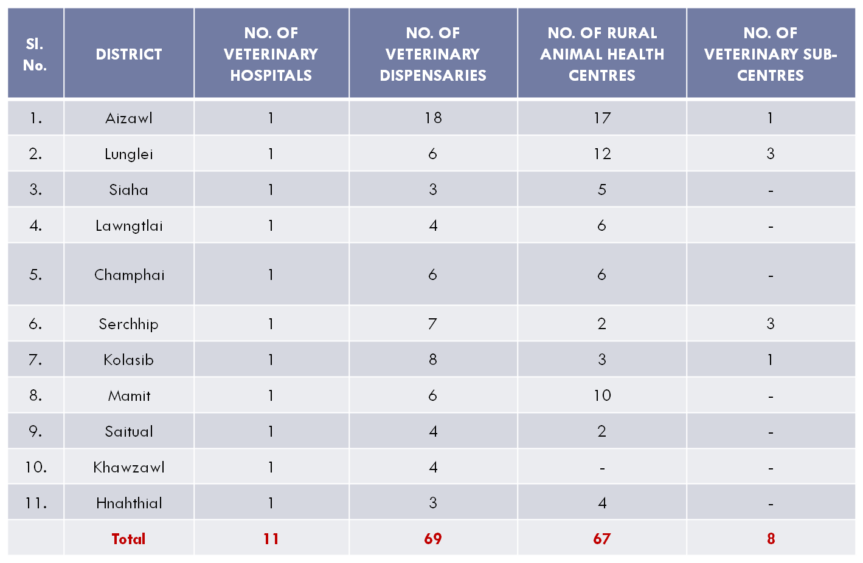

- Services available at Hospitals and Dispensaries:
  - Treatment of sick animals of both large and small including major and minor surgeries.
  - Immunization against contagious and infectious diseases.
  - Artificial Insemination in cattle and pig.
  - Consultation.
  - Meat inspection.
  - Post-mortem investigation.
  - Dispensing.
- Services available at Rural Animal Health Centre:
  - Treatment of sick animals both large and small.
  - Vaccination against contagious diseases of livestock and poultry.
  - Minor surgical operations like castration and ovarectomy, minor injury, etc.
  - Dispensing.
- AI in selected centres only.

- Disease Investigation: A separate Disease Investigation wing is set up within the Department
to prevent, control, investigate, diagnose and survey the occurrence of animal and poultry diseases within the State.

- Livestock Development: The term “livestock” in broad sense, includes all animals, birds and other living creatures used for producing products for the use of man. These animals and birds are mainly reared in commercial farms or backyards. Livestock provides food items such as milk, meat and eggs for human consumption. Livestock is considered as “moving banks” because of their potentiality to dispose off during emergencies.
3.1. Cattle Development: The Department is maintaining 7(seven) Cattle Farms and 4(four) Calf Rearing Farms within the State. Cattle Farms at Thenzawl, Mampui, Lungpuizawl (Lunglei), Selesih, Thingdawl and Siaha.
Calf Rearing Farms at Selesih, Kolasib, Champhai and Lungpuizawl (Lunglei).
3.2. Piggery Development: The Department is now maintaining the following Piggery Farms:-
- Pig Mega Seed Farm, under ICAR, Selesih
- Piglet Multiplication Farm, Thingsulthliah.
- Base Pig Farm, Lungpuizawl, Lunglei.
- Zovawk (Indigenous Pig) Farm, Lungpuizawl, Lunglei
- Piggery Farm, Mampui, Lawngtlai.
- Piggery Farm, Thingdawl, Kolasib.
- Regional Boar Semen Station, Selesih.
3.3. Goat Breeding: The Department is currently maintaining 1(one) Goat Breeding Farm at Thenzawl.
3.4. Poultry Development: The Department at present maintained Poultry Farms at Selesih, Tanhril, Lunglei, Siaha, Thingdawl, Champhai, Mampui, Serchhip, Thenzawl and Mamit. These farms serve as training and demonstration centres, supply of brooded chicks and table eggs, sale of culled birds and manure production.
- Feed and Fodder Development:
4.1 Animal Feeds: The Department is running one Animal Feed Plant at Tuivamit, Ramrikawn with the average production of 3 ton per day. The readymade various animal feeds are sold to public; available at Tanhril and Department Sales Emporium, Khatla, Aizawl.
4.2 Fodder cultivation : Mass fodder cultivation at AH &Vety Farm, Thenzawl with fodders like Congo Signal, Guinea grass, Pennisetum spp., Napier hybrid.

- Extension and Education &Trainings :
5.1 Integrated Animal Husbandry & Veterinary Training Institute at Lunglei (Lungpuizawl): With 24 students capacity, it is a Paravet training institute with two years course.
5.2 Artificial Insemination training centers: Two (2) nos of A.I. training centres at Selesih and Sihphir.
5.3 Ranvulhpuitu: A magazine ‘Ranvulhpuitu’ is published quarterly, targeting pet owners, livestock and poultry farmers and can be obtained free of cost.

- Clean meat production : Two numbers of Slaughter houses at Mualpui and Bawngkawn, to ensure clean and hygienic meat production and distribution.

- Biogas: The Department is designated Nodal Agent for National Biogas and Manure Management Programme, a Centrally Sponsored programme, Mizoram.

Ongoing Projects

- Call Centre under NADCP:
- The Department of Animal Husbandry & Veterinary, Mizoram has received fund under the central sector scheme NADCP for FMD and Brucellosis for establishment of Call Centre at Aizawl for the operationalization of Mobile Veterinary Unit (MVU), monitoring and surveillance of FMD and Brucellosis vaccination in the state.
- The scheme envisages the Call Centre to be manned by technical persons like Call Centre executive, call centre agent and IT support staff to enable doorstep delivery of veterinary services covering all development blocks in the State.
- The Call Centre will function on the ground by calling up beneficiaries (livestock owners) over telephone.
- It will ascertain vaccination works, A.I and other work for upgrading their livestock.

- Mobile Veterinary Unit (MVU):
- MVU in our veterinary service delivery system is designed as an alternative model of rural animal health care delivery for a specified area with earmarked team of veterinary professionals with supporting equipments and drugs.
- It is established to strengthen the service delivery mechanism through which farmers can get health care, breeding and advisory services for their livestock at doorstep in the interior villages where veterinary institutions are far away.
- It will also be helpful for providing services during outbreak of diseases, public emergencies and natural calamities.
- Objectives of MVU:
  - To provide Livestock Healthcare at farmers’ doorstep.
  - To detect the common diseases prevalent in the area.
  - To provide “on the spot” free diagnostic services.
  - To make disease surveillance and monitoring of livestock and poultry diseases.
  - To control and contain disease outbreak.
  - To popularise the departmental schemes.
  - To create awareness on livestock preventive healthcare and other department services available.

- Bio-safety Level-II Molecular Laboratory:
- With the emergence of trans-boundary diseases and looking into the Global trend in disease outbreaks and the potential to cause a pandemic, many of the diagnosis cannot be made nor the agents handled in the existing Disease Investigation Laboratory of the Department of Animal Husbandry & Veterinary, Mizoram according to the recommendations established by the Centre for Disease Control and Prevention (CDC) and OIE.
- Therefore, establishment of Bio-safety Level – II Laboratory is much needed to ensure the safety of lab personnel and prevent the spill-over effect of disease to the public, through efficient waste management.
- Objectives of BSL-II:
- Increasing efficiency of Animal Disease Diagnostic System.
- Providing better safety measures to the laboratory personnel.
- Better control of bio-hazardous waste from the laboratory.
- Preventing leakage TADs and zoonotic diseases from the laboratory.
- Better planning and prediction of future trans-boundary animal disease outbreaks.
- Building strong advisory network to the farmers.
- Better knowledge on zoonotic diseases dynamics in the state.
- In depth study on zoonotic diseases and microbial resistance impacting the public health.

Projects and Schemes Implemented (2019-2020)
- National Livestock Mission (NLM)
- Rashtriya Krishi Vikas Yojana (RKVY)
- Peste-des-petits Ruminants Control Programme (PPR-CP)
- Classical Swine Fever Control Programme (CSF-CP)
- National Animal Disease Control Programme (NADCP)
- Assistance to State for Control of Animal Diseases (ASCAD)
- Professional Efficiency Development (PED)
- National Animal Disease Reporting System (NADRS)
- Nationwide Artificial Insemination Programme (NAIP)
- New National Biogas and Organic Manure Programme (NNBOMP)
- National Project on Rinderpest Surveillance and Monitoring (NPRSM)
- Rashtriya Gokul Mission (RGM).
- Integrated Sample Survey Scheme.
- Quinquennial Livestock Census.
- Socio-Economic Development Programme (SEDP)
- INDBRO Poultry Hatchery Farm, ZPDS, Tanhril.

Zoram Poultry Development Society (ZPDS)
Zoram Poultry Development Society’s INDBRO Poultry Hatchery Farm, Tanhril is established under the Project name of “Establishment of Hatchery Farm at Tanhril, Aizawl” using funds from RIDF (XVII) 2012 – NABARD. The Farm was inaugurated on the 18th of May 2015 and is fully functioning since its inauguration.
Objective :- The Primary objective of ZPDS INDBRO Poultry Hatchery farm, Tanhril as its name suggest, is the production of high performance breed of Day old chicks at prices affordable to farmers, to initiate self sufficiency of the state of Mizoram in egg and poultry meat production by marketing high performance low cost chicks. The farm is equipped with genetically superior birds, capable of high production in terms of meat and eggs even in adverse conditions. Day old Chicks (DoC) produced in the farm is marketed at Rs. 45/chick for unsexed Brown Layers and Dual purpose Rainbow Roosters, against market price of Rs.80/unsexed chick with unknown performance imported from outside the state. Broiler chicks hatched at ZPDS Hatchery are sold at a rate of Rs.50-60/Doc as against the market price of Rs.70-80/chick from private dealers with unproven growth performance who import them from other states.
Infrastructures at ZPDS INDBRO Poultry Hatchery Farm :-
1) Hatchery building complete with 6 incubators viz. 4 (four) Setting Machine and 2 Hatching Machine.
a) Setting Machine:- 4 numbers, each with a capacity to incubate 15,000 eggs, with a full capacity to incubate 60,000 eggs at one setting or a capacity to incubate 20000 eggs every week.
b) Hatching machine:- 2 numbers, each with a capacity to hatch 10000 chicks.
2) Layer houses:- 2 numbers, with a capacity to house 6000 layers or 3000 Broiler Parents stock. Additional layer house with 4000 birds capacity is being utilised.
3) Brooder cum Grower House with a capacity to Brood 4000 birds till pullet stage.
4) Office building completed with Farmers Training room-cum-conference room.
5) Egg storage with Air conditioning system for storing Fertile/Hatching eggs.
Projects for Augmentation of ZPDS Hatchery
Two Projects were submitted to the Government of Mizoram for augmenting the current production capacity of 20,000 chicks per week to a tune of at least 60,000 chicks per week. Success of these projects will result in the production of good quality chicks at lower selling rate which will immensely benefit the Poultry farmers as well as poultry meat and egg consumers. The two projects are as follows.
a)Augmentation of Zoram Poultry Development Society’s INDBRO Poultry Hatchery Farm, Tanhril Mizoram with TFO amounting to Rs.3.73 Cr, submitted to AH&Vety.Dept. on 20th July 2020 to be funded under NABARD RIDF XXVI with components includes
1) Extension of Hatchery Building & Installation of Incubators capable of producing an additional 40000 chicks/week.
2) Construction of Sedimentation tank, Strengthening of Pond, Construction of MD Quarters, Refurbishing of Brooder House, Bio-security fencing, Construction of Staff Quarters, Installation of submersible pump, installation of RO water filtration system, Development of Marketing Network etc.
b) Upgrading of INDBRO Hatchery Farm of Zoram Poultry Development Society at Tanhril with TFO amounting to Rs.4.45 Cr. Submitted to Planning & Programme Implementation Dept. through AH & Vety. Department on the 17th Nov 2020 to be funded under Special Assistance to State for Capital Expenditure with Components including
1) Construction of Hatchery Building with installation of Hatchery equipments for production of 40,000 chicks/week in addition to the existing production capacity.
2) Construction of Feeds Go-down.
3) Installation of 3 nos. of Rainwater Harvesting Tank, each with 1.5 lakhs litre capacity for Hatchery, Brooder and Breeder House.
4) Refurbishing of Breeder House.
5) Construction of Carcass Disposal pit.
6) 30kWP Grid connected rooftop Solar System etc.

